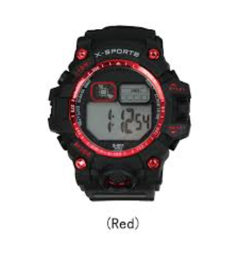

### ****Product Name****

**X-SPORTS Digital Wristwatch (Red Accent)**

### ****Description****

A sporty digital wristwatch designed for active users. Features a bold black and red color scheme, a durable body, and an easy-to-read digital display.

### ****Specifications****

* **Display:** Digital time display
* **Design:** Black with red accents
* **Functions:** Likely includes stopwatch, alarm, backlight, and possibly water resistance
* **Strap:** Durable material, possibly rubber or silicone

### ****Price****

15,000$